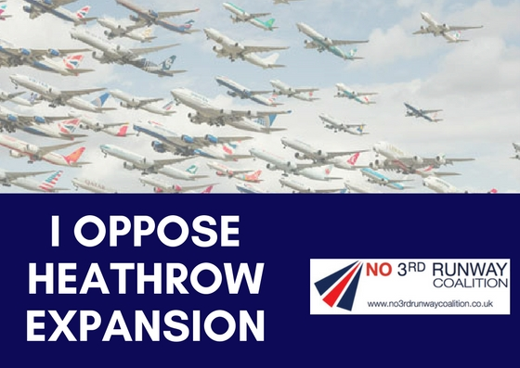

I/ we the undersigned believe that expansion at Heathrow cannot be delivered for the following reasons (please tick all that apply):

‘High risk’ of continuing to breach legal air quality limits

Significant surface access costs to be paid by taxpayer

Overstated economic benefits & damaging to the regions.
300,000 more people adversely impacted by noise

3,750 homes destroyed or made uninhabitable

Comment:

Name: _______________ Signature: __________________

Address: ____________________________________________________________

Email to: RunwayConsultation@dft.gsi.gov.uk Write to: Freepost RUNWAY CONSULTATION

